CSS Quiz 2

**Consider the following code**

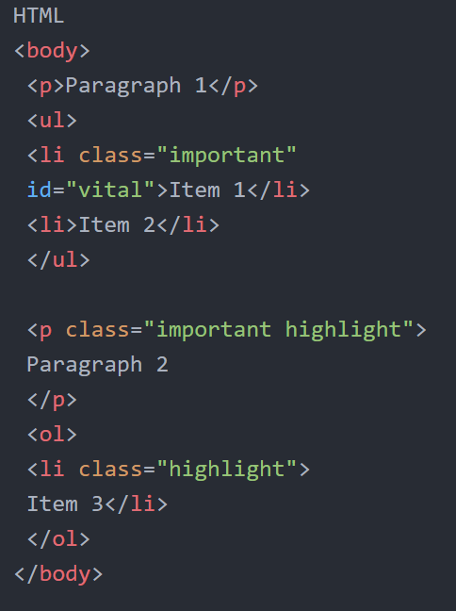

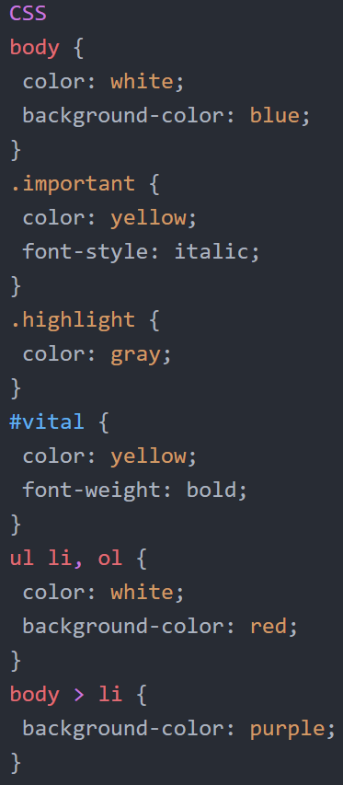

All following questions are based on the code above. Please choose the correct colour/style

1. Paragraph 1 **background-color**
   1. Blue
   2. Red
   3. Purple
   4. None of the above
2. Paragraph 1 **color**
   1. white
   2. yellow
   3. grey
   4. None of the above
3. Paragraph 1 **font-style**
   1. italic
   2. normal
   3. oblique
   4. None of the above
4. Paragraph 2 **background-color**
   1. Blue
   2. Red
   3. Purple
   4. None of the above
5. Paragraph 2 **color**
   1. white
   2. yellow
   3. grey
   4. None of the above
6. Paragraph 2 **font-style**
   1. italic
   2. normal
   3. oblique
   4. None of the above
7. Item 1 **background-color**
   1. Blue
   2. Red
   3. Purple
   4. None of the above
8. Item 1 **color**
   1. white
   2. yellow
   3. grey
   4. None of the above
9. Item 1 **font-style**
   1. italic
   2. normal
   3. oblique
   4. None of the above
10. Item 2 **background-color**
    1. Blue
    2. Red
    3. Purple
    4. None of the above
11. Item 2 **color**
    1. white
    2. yellow
    3. grey
    4. None of the above
12. Item 2 **font-style**
    1. italic
    2. normal
    3. oblique
    4. None of the above
13. Item 3 **background-color**
    1. Blue
    2. Red
    3. Purple
    4. None of the above
14. Item 3 **color**
    1. white
    2. yellow
    3. grey
    4. None of the above
15. Item 3 **font-style**
    1. italic
    2. normal
    3. oblique
    4. None of the above

Code as Text

HTML

<body>

<p>Paragraph 1</p>

<ul>

<li class="important"

id="vital">Item 1</li>

<li>Item 2</li>

</ul>

<p class="important highlight">

Paragraph 2

</p>

<ol>

<li class="highlight">

Item 3</li>

</ol>

</body>

CSS

body {

color: white;

background-color: blue;

}

.important {

color: yellow;

font-style: italic;

}

.highlight {

color: gray;

}

#vital {

color: yellow;

font-weight: bold;

}

ul li, ol {

color: white;

background-color: red;

}

body > li {

background-color: purple;

}